Accepts any string in 01*0

Adapted from Neso Academy

Accepting input string: 010

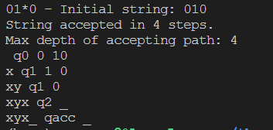

Rejecting input string: 0101

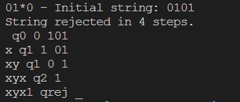

Steps:

Step-0: If the symbol is 0, replace it with x, move right, and transition to state q1. If the symbol is 1, ignore it, move right, and transition to state qrej.

Step-1: If the symbol is 0, ignore it, move right, and remain in state q1. If the symbol is 1, ignore it, move right, and transition to state q2.

Step-2: If the symbol is _ (blank), ignore it, move right, and remain in state q2. If the symbol is 1, ignore it, move right, remain in state q2. If the symbol is 0, replace it with x, move right, and transition to state q3.

Step-3: If the symbol is _ (blank), ignore it, move right, and remain in state q3. If the symbol is 1, ignore it, move right, and remain in state q3. If the symbol is 0, ignore it, move right, and remain in state q3. If the symbol is x, ignore it, move left, and transition to state q0.

Step-4: If the symbol is 1, ignore it, move left, and transition to state q4. If the symbol is _ (blank), ignore it, move left, and transition to state q4.

Step-5: If the symbol is 1, replace it with y, move right, and transition to state q5. If the symbol is _ (blank), ignore it, move right, and transition to state q7.

Step-6: If the symbol is _ (blank), ignore it, move right, and remain in state q6. If the symbol is 1, ignore it, move right, and remain in state q6. If the symbol is 0, replace it with x, move left, and transition to state q8.

Step-7: If the symbol is _ (blank), ignore it, move left, and remain in state q7. If the symbol is 1, ignore it, move left, and remain in state q7. If the symbol is y, ignore it, move right, and transition to state q5.

Step-8: If the symbol is _ (blank), ignore it, move right, and remain in state q8. If the symbol is 1, ignore it, move right, and transition to state q8. If the symbol is $, ignore it, move left, and transition to state qacc.

Step-9: The string is ACCEPTED.

State diagram:

